Design Document

CS 4321 - Software Engineering 1

Group *8* – BARTS

Tyler Cabutto, Brandon Little, Andrew Simpson, Robert Walker

10/26/2015

1. **Architectural Design**

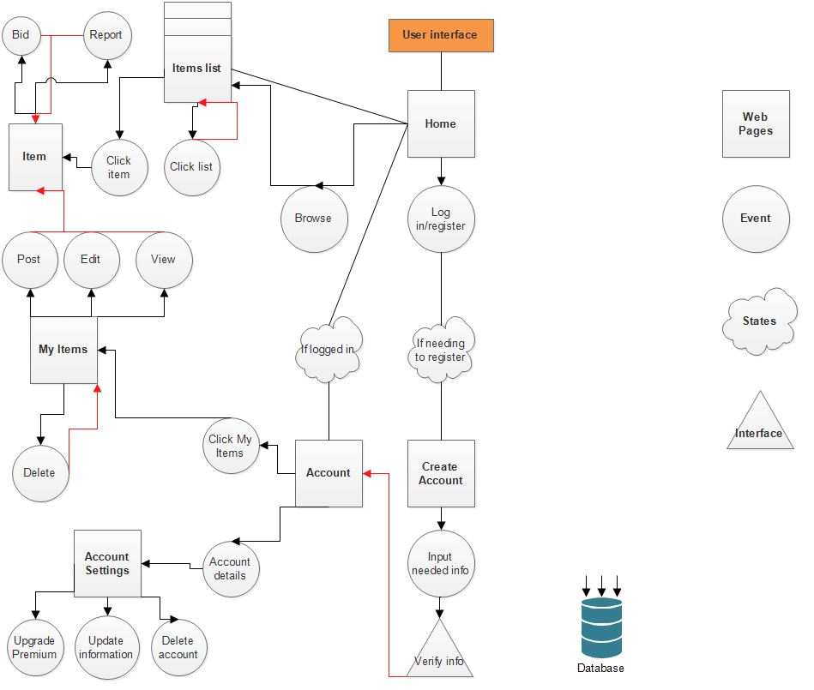

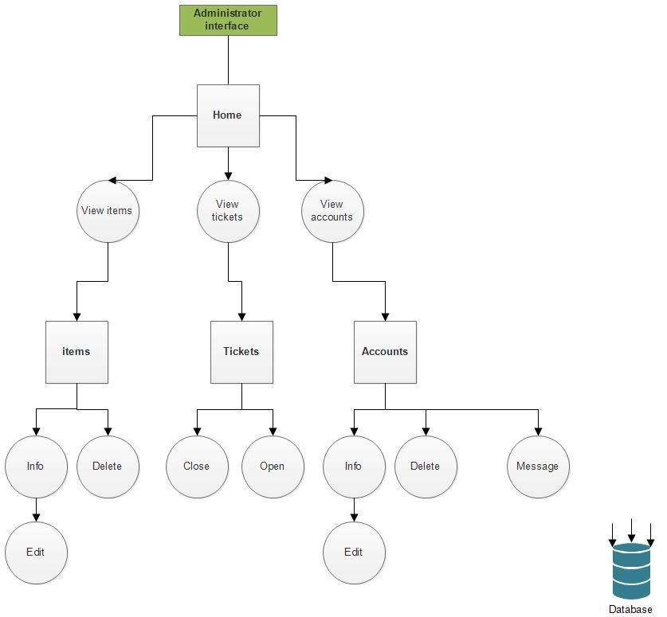

1. **Low Level Design**

**2.1 Class Diagrams**

**User interface**

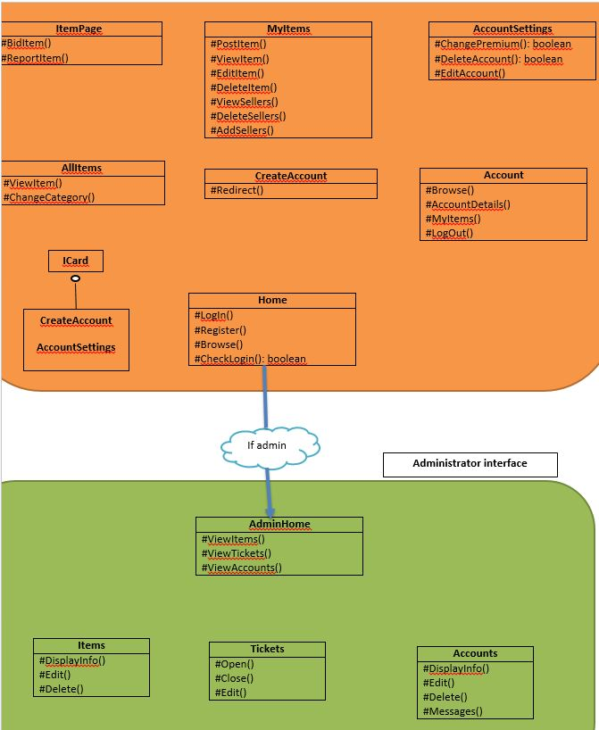

|  |
| --- |
| **User** |
| **-boolean premium** |
| **-String email** |
| **-String password** |
| **-String dateCreated** |
| **-String name** |
| **-Item[] listings** |
| **-Item[] items** |
| **-User[] sellers** |
| **-User manager** |
| **-String payment** |
| **#PostItem()** |
| **#DeleteItem()** |
| **#EditItem(String val)** |
| **#GetItem(int key)** |
| **#User()** |
| **#Bid(double val)** |
| **#DeleteAccount()** |
| **#SendTicket()** |

|  |
| --- |
| **Item** |
| **-String name** |
| **-int key** |
| **-double price** |
| **-String category** |
| **-User Owner** |
| **-User Seller** |
| **#Item()** |

**0…50**

|  |
| --- |
| **DB_Main** |
| String ticket |
| Users |
| Items |

|  |
| --- |
| **Administrator** |

|  |
| --- |
| **Ticket** |
| -int id |
| -String category |
| -String subject |
| -User submitter |
| -boolean status |

**2.2 Sequence Diagrams**

***Close Ticket***

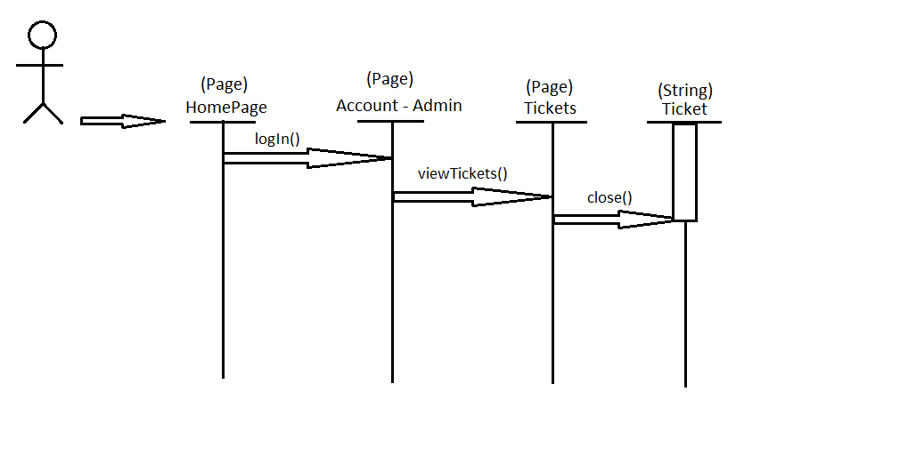

**Create Account**

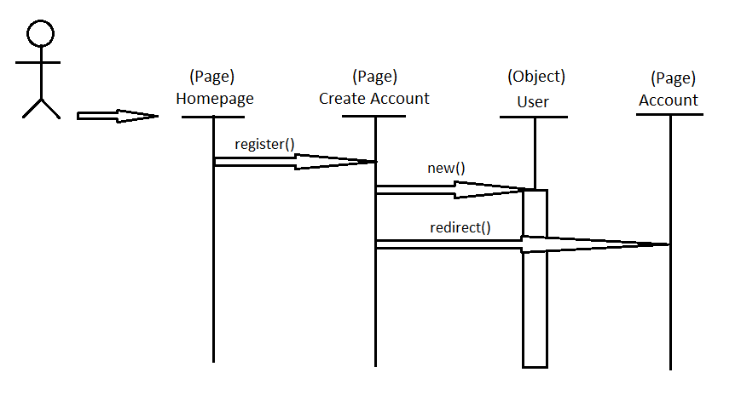

**Post Item**

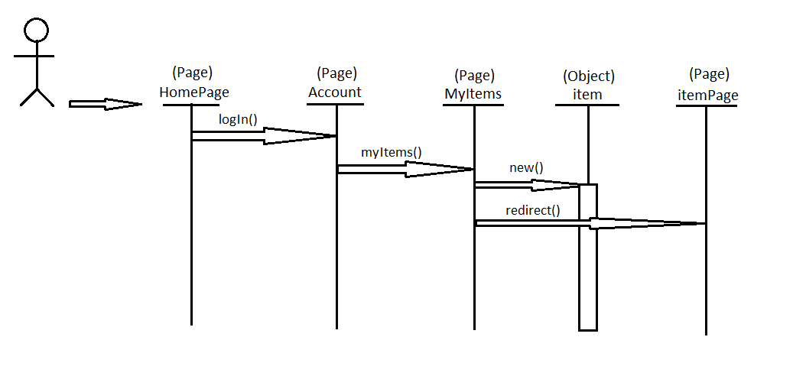

1. **User Interface**

